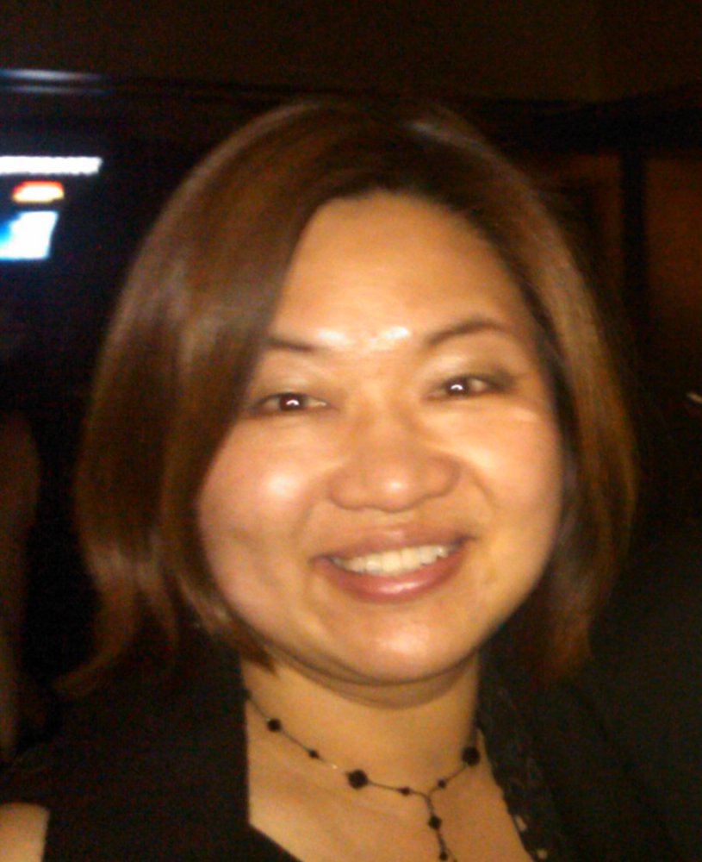

**Lin Sun-Hoffman, Ph.D., J.D.**

**Sun-Hoffman Consulting.**

Dr. Sun-Hoffman is a licensed US patent attorney.  She currently consults in biotech, pharmaceutical in IP and transactional areas. She also assists businesses expand into China through providing strategic and practical advice on issues as diverse as government relations, research and/or business partnerships between Chinese and American companies, intellectual property protection and drug regulatory matters.

From 2009 to present， Dr. Sun-Hoffman was the Chief Advisor for China at Grocery Manufacturers Association and previously was Chief Advisor for Asia at Biotechnology Industry Organization (BIO).  Dr. Sun-Hoffman held positions at Life Technologies Corporation (now Thermo Fisher, formerly Applied Biosystems) as a Senior Patent Attorney and as a managing patent attorney at Celera Genomics.  She is also a former patent examiner at USPTO. She has more than 10 years of biomedical research experience including several years as a postdoctoral research fellow at the National Institutes of Health (NIH) in Maryland.

Dr. Sun-Hoffman is active in several nonprofit organizations. She recently serves as SF leader for Bayhelix Group, board member of US-China Green Energy Council, vice chair of IUTG subcommittee at LESI. She previously served as President for Chinese Bioscience Association in Silicon Valley, President of Chinese Biopharmaceutical Association (CBA) in Washington DC.

Dr. Sun-Hoffman received her Juris Doctor (J.D.) degree from University of Maryland School of Law; Ph.D. in Biochemistry, from the University of Nevada Reno, and a B.S. in Biology from East China Normal University, Shanghai, China. Dr. Sun-Hoffman is admitted to the Maryland Bar and she is registered to practice before the U.S. Patent and Trademark Office.