E
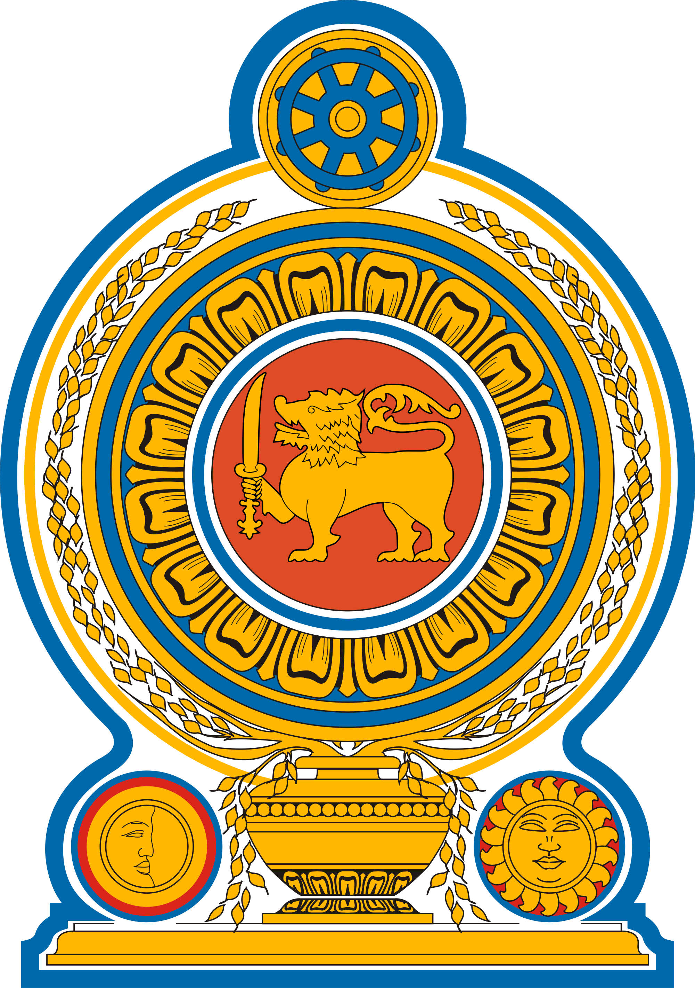
National Intellectual Property Office  of Sri Lanka |  | 
WORKSHOP (Online)

WORLD IP DAY 26.04.2023

Theme : Women and IP

organized by
the National Intellectual Property Office of Sri Lanka (NIPO)

in collaboration with
the World Intellectual Property Organization (WIPO)

26 April 2023

PROVISIONAL program

Wednesday, April 26, 2023

Morning Session

Registration link

https://zoom.us/meeting/register/tJMqd-mtpzsoHtdl8G2gbLDQuuf5T6N-ab3s

9:30 – 9:35 Welcome Address by Mrs. Geethanjali Ranawaka, Director General of, NIPO : Need for women contribution to the IP world.

9:35 – 10:00 Women in the IP world / interview or video demonstration

10.00 – 10.30 TM and Registration Process (Ms. Nishani Nishshanka, Assistant Director (legal), NIPO)

10.30 – 11.00 Copyright System in Sri Lanka (Mr. Prasanga Pandithasundara, Asistant Director (Legal), NIPO)

11:00 – 11:15 Industrial Designs and Registration (Ms. Dilini Rathnayake, Assistant Director (Information and Examination), NIPO)

11.15 - 12 00 Inventions and Patenting Process (Mr. Nalinda Atapattu, Assistant Director (Information and Examination), NIPO)

Afternoon Session

Meeting link

https://wipo-int.zoom.us/j/65022505897?pwd=aFdLVitNZDhVOFd6UjdTRHBUdCsrdz09

13:30 – 14:15 Usefulness and Value of Patent Information in Supporting Innovation and Technology Innovation Support Centers (TISCs)

Speaker: Mussadiq Hussain, Head, Technology Information
Section, IP for Innovators Department, WIPO

14.15 – 15.00 WIPO INSPIRE and Digital Support Resources for TISCs

Speaker: Meklit Jaleta, Product Owner, Technology Information Section, IP for Innovators Department, WIPO

15:00 – 16:00 How to draft a complete patent application: an examiner’s view point (Guest Speaker – Dr. Lutz Mailander, )

