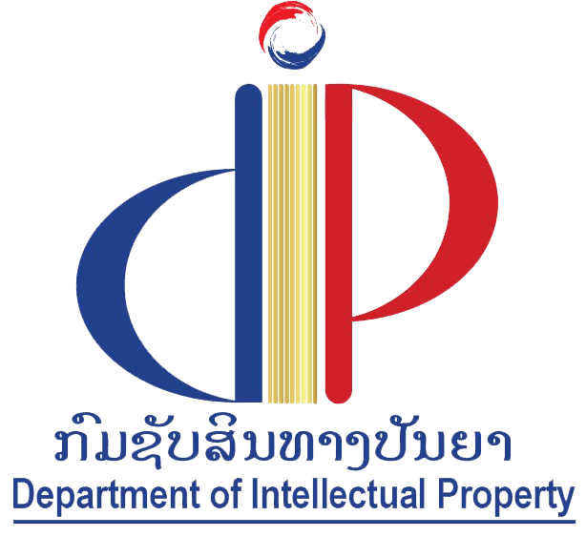 |  | 
Department of Intellectual Property,  Ministry of Industry and Commerce, Lao People's Democratic Republic | Japan Patent Office

regional meeting
WIPO/REG/TISC/VTE/24/Inf/1 prov.
ORIGINAL: English
DATE: February 7, 2024

WIPO Regional Meeting on Strengthening the ASEAN Regional Technology and Innovation Support Center (TISC) Network

organized by
the World Intellectual Property Organization (WIPO)

and
the Department of Intellectual Property, Ministry of Industry and Commerce, Lao People's Democratic Republic

with support from
the Japan Patent Office (JPO)

Vientiane, March 21 and 22, 2024

Provisional program

prepared by the International Bureau of WIPO

Thursday, March 21, 2024
9.00 – 9.30 | Registration
9.30 – 10.00 | Opening Ceremony
 | Welcome addresses:
Mr. Xaysomphet Norasingh, Director General, Department of Intellectual Property, Ministry of Industry and Commerce, Lao People's Democratic Republic

Mr. Andrew Czajkowski, Director, Technology and Innovation Support Division, IP for Innovators Department, IP and Innovation Ecosystems Sector, WIPO, Geneva
10.00 – 10.45 | Theme 1 | New Developments in the Global TISC Program  - New Product Development (NPD) Toolkit  - TISC Staff Certification Program  - TISC Project and Performance Management (TPPM) Platform
 |  | Speaker: Mr. Alex Riechel, Head, TISC Development Section, Technology and Innovation Support Division, IP for Innovators Department, IP and Innovation Ecosystems Sector, WIPO, Geneva
10.45 – 11.00 | Coffee Break
11.00 – 11.45 | Theme 2 | WIPO Initiatives related to TISCs  - ASEAN Regional IP Policy (ARIPP) Model  - IP Valuation Toolkit  - Others
 |  | Speaker: Ms. Nathalie Montillot, Program Officer, TISC Development Section, Technology and Innovation Support Division, IP for Innovators Department, IP and Innovation Ecosystems Sector, WIPO, Geneva
11.45 – 12.30 | Theme 3 | ASEAN Initiatives related to TISCs
 |  | Speaker: Representative from the ASEAN Secretariat, Jakarta
12.30 – 14.00 | Lunch Break
14.00 – 15.15 | Theme 4  (Part 1) | TISCs – The ASEAN Way  - TISC Report Highlights  - TISC Workplan 2024 and beyond
 |  | Speakers: The Representatives of Brunei Darussalam, Cambodia, Indonesia, and Lao PDR
15.15 – 15.30 | Coffee Break
15.30 – 17.00 | Theme 4  (Part 2) | TISCs – The ASEAN Way  - TISC Report Highlights  - TISC Workplan 2024 and beyond
 |  | Speakers: The Representatives of Malaysia, Philippines, Thailand, and Viet Nam

Friday, March 22, 2024
9.30 – 10.15 | Theme 5 | Building an Integrated Innovation Ecosystem
 |  | Speaker: Representative from Singapore
10.15 – 10.30 | Coffee Break
10.30 – 12.30 | Theme 6 | Building a Sustainable TISC Network  - Selecting TISC host institutions  - Building commitment from TISC host institutions  - Maintaining engagement from TISC host institutions
 |  | Speakers: The Representatives of Indonesia, Malaysia, Philippines, Thailand, and Viet Nam
12.30 – 14.00 | Lunch Break
14.00 – 15.00 | Theme 7 | Joint IP and Innovation Activities  - Updates on proposed/ongoing joint activities for the biennium 2024-2025  - Opportunities for developing these activities (potential AMS partners, required support)
 |  | Speakers: Representatives from Malaysia and Indonesia, Cambodia and Philippines, Indonesia, Viet Nam and ASEC
15.00 – 15.15 | Coffee Break
15.15 – 16.45 |  | Opportunities for ASEAN Regional TISC Cooperation
 |  | Moderator: Mr. Alex Riechel
16.45 – 17.00 | Closing Remarks
Mr. Andrew Czajkowski
Mr. Xaysomphet Norasingh

[End of document]

