E
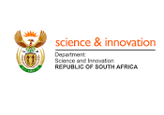 | 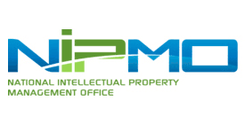 | 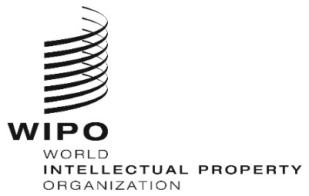
department of science and innovation | national intellectual property management office (NIPMO)
HYBRID
WIPO/TISC/JNB/24/ INF/PROV 1
ORIGINAL: English
DATE: January 17, 2024

WIPO Hybrid Workshop on Intellectual Property Commercialization in South Africa

organized by
the World Intellectual Property Organization (WIPO)

in cooperation with
the Department of Science and Innovation

and with the assistance of
the National Intellectual Property Management Office (NIPMO)

Hybrid, March 6 to 8, 2024

PROVISIONAL PROGRAM

prepared by the International Bureau of WIPO

Wednesday, March 6, 2024
(Local time in Johannesburg, South Africa)

8.30 – 8.45 Registration

8.45 – 9.00 Opening Ceremony

Opening Remarks by:

Ms. Jetane Charsley, Head, National Intellectual Property Management
Office (NIPMO), Pretoria

Mr. Andrew Czajkowski, Director, Technology and Innovation Support Division, IP for Innovators Department, IP and Ecosystems Sector, World Intellectual Property Organization (WIPO), Geneva (virtual)
9.00 – 9.30 Theme 1 Update on the Global TISC network

Speaker: Ms. Naana Halm, Program Officer, TISC Development Section, IP for Innovators Department, IP and Ecosystems Sector, WIPO (onsite)

9.30 – 10.00 Theme 2 How to turn IP into a commercially valuable asset

Speaker: Dr. Charlene Musiza, Academic Researcher and Consultant, Zimbabwe (virtual)

10.00 – 10.30 Coffee break

10.30 – 11.30 Theme 3 Creating value out of IP - General principles

Speaker: Mr. Omer Hiziroglu, Consultant, Azur Strategy,
France (onsite)

11.30 – 12.30 Theme 4 Value generation: Protection strategies in view
of monetization

Speaker: Mr. Omer Hiziroglu

12.30 – 14.00 Lunch break

14.00 – 15.00 Theme 5 Commercialization pathways

Speaker: Mr. Omer Hiziroglu

15.00 – 16.00 Theme 6 Group study fact pattern exercises

Speaker: Mr. Omer Hiziroglu

[End of day 1]

Thursday, March 7, 2024

9.00 – 10.00 Theme 7 Valuation of IP

Speaker: Dr. André Gorius, International IP Valuation
Expert, President of GOVALIA, CEO JMB SAS, Partner at WINNOTEK, France (virtual)
10.00 – 10.30 Coffee break

10.30 – 11.30 Theme 8 Licensing your IP rights – Key Issues

Speaker: Dr. André Gorius

11.30 – 12.30 Theme 9 Essentials of the Negotiation Deal

Speaker: Dr. Simon Thanyani, Contracts and Innovation Support Manager, University of Pretoria, South Africa

12.30 – 14.00 Lunch break

14.00 – 15.00 Theme 10 Practical exercises

Moderator: Ms. Ntanganedzeni Muanalo Director: Regulatory and Compliance, National Intellectual Property Management Office (NIPMO)

[End of day 2]

Friday, March 8, 2024

9.00 – 10.00 Theme 11 Demystifying IP audit and Due Diligence

Speaker: Ms. Margherita Marini, IP Commercialisation Specialist, IP Commercialisation Section, IP for Innovators Department, IP and Ecosystems Sector (virtual)

10.00 – 10.30 Coffee break

10.30 – 11.30 Theme 12 IP Marketing tools & strategies

Speaker: Mr. Omer Hiziroglu

11.30 – 12.30 Theme 13 Intangible Assets Finance

Speaker: Mr. Michael Kos, IP Finance and Valuation Specialist, IP Commercialisation Section, IP for Innovators Department, IP and Ecosystems Sector (virtual)
12.30 – 14.00 Lunch break

14.00 – 15.00 Theme 14 Review of concepts through group study

Speaker: Mr. Omer Hiziroglu

15.00 – 15.30 Close

[End of document]

Johannesburg is one hour ahead of Geneva

