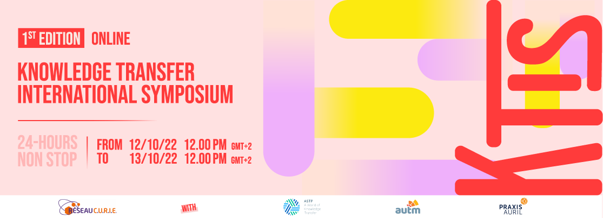
[BREAKING NEWS]
The Knowledge Transfer International Symposium is now open to all for registration!
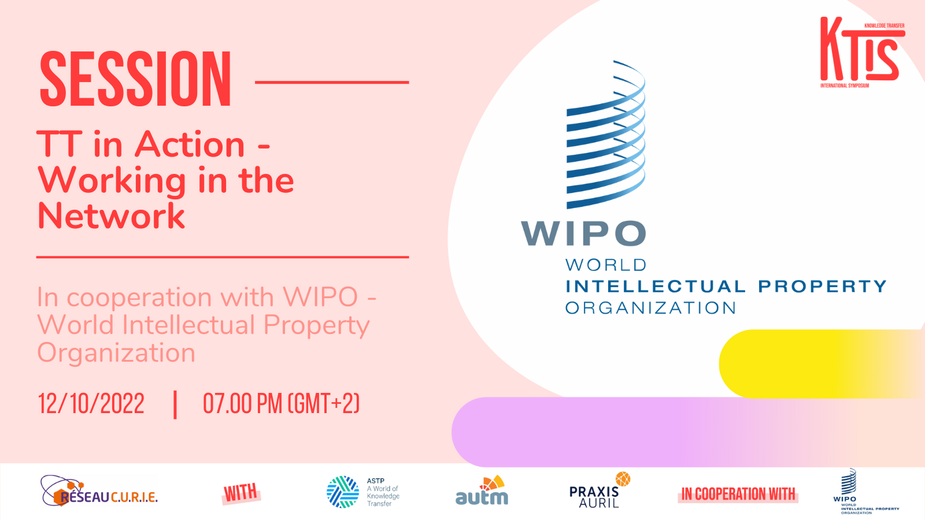

Details of the global summit
Reseau C.U.R.I.E and its partners ASTP, AUTM and Praxis AURIL, in cooperation with WIPO, are pleased to announce the first Knowledge Transfer International Symposium: 24 hours non-stop from the 12th of October 2022 (12 am GMT+1) to the 13rd of October (12am GMT+1)

The Knowledge Transfer (KT) International Symposium will gather all KT professionals, from junior to senior profiles, for a 24 hours digital event.

Dedicated to KT, this 24 hours program will be divided in two parts: “KT let’s talk about: make researchers want to transfer” and “KT let’s talk about supply and demand”.

WIPO will have two Panel Sessions:
- 12 Oct 2022, 18:00 (Geneva time): Panel on Incentives in Technology Transfer – How to Encourage, Recognize and Reward Faculty Researchers and Support Staff
- 12 Oct 2022, 19:00 (Geneva time): TT in Action - Working in the Network

Experts will be available online to answer any questions from the audience!

👉 Program available here

Register now

